



毕业设计（论文）外文资料
原文及译文

专 业 网络工程
班 级 19104341
学 号 1910400639
姓 名 霍英豪
指 导 教 师 蒋旻隽

原文出处： | ITB J. ICT Vol. 3, No. 1, 2009, 1-18

The Investigation on Using Unity3D Game Engine in Urban Design Study
¹Aswin Indraprastha & ²Michihiko Shinozaki

¹Graduate Student, Architecture and Urban Design Program Department of Design and Engineering, Shibaura Institute of Technology
Shibaura 3-9-14 Minato-ku Tokyo 108-8548 Japan Email aswinindra@gmail.com

²Professor, Architecture and Urban Design Program, Department of Design and Engineering, Shibaura Institute of Technology,
Shibaura 3-9-14 Minato-ku Tokyo 108-8548 Japan Email sinozaki@shibaura-it.ac.jp

Abstract. Developing a virtual 3D environment by using game engine is a strategy to incorporate various multimedia data into one platform. The characteristic of game engine that is preinstalled with interactive and navigation tools allows users to explore and engage with the game objects. However, most CAD and GIS applications are not equipped with 3D tools and navigation systems intended to the user experience. In particular, 3D game engines provide standard 3D navigation tools as well as any programmable view to create engaging navigation thorough the virtual environment. By using a game engine, it is possible to create other interaction such as object manipulation, non playing character (NPC) interaction with player and/or environment. We conducted analysis on previous game engines and experiment on urban design project with Unity3D game engine for visualization and interactivity. At the end, we present the advantages and limitations using game technology as visual representation tool for architecture and urban design studies.

Keywords: architecture; game engine; interactive virtual environment; urban design study; visual representation.

Beyond Architectural Visualization
Architectural and urban design is always about idea of visualization and materialization. The importance of visualization is so crucial that two- dimensional and three-dimensional graphics take the most part in design stages. Throughout history, architectural drawings became major media for architects to present ideas and visions to society. It is not surprising that information of ideas and visions are more important for the society (or, clients) than technical or engineering drawing references. The term architectural visualization refers to the media in which architects used to communicate the ideas to the clients.

The trend of architectural visualization comes up to the point that makes depiction of real world as realistic as possible or even hyper-realistic. By the increasing speed of computer processor and amount space in memory, this trend also demands huge computer resources to render and to animate visualization sequences. The basic role of architectural visualization is no longer for the communication purpose only but also for broader scope and functions such as collaborative design process and marketing. At the same time, design process itself transformed into more parallel and multi-tasking activities. Design visualization is needed not only as the culmination of design development but as the input for design strategy as well.

Objectives
The objective of this study is to identify the advantages and limitations of using game engine-based application for visual representation tool in urban design study. By understanding its potentials and limitations, we are able to develop new media for visual representation that integrates CAD applications with real- time interactive animation.

Related Researches
Game engine-based environment on a particular urban area could be a tool to assist 3D visual simulation for policy maker and every stakeholder in design study and process [1, 2]. Oxman noted [3] that as the basis for visualization tool, game engines have basic advantage to save implementation time by reusing its built-in functionalities such as rendering engines, navigations and interaction tools. Modern game engines offer a high speed, rendering quality, interactivity and multi-user support that are difficult to obtain using any existing visualization tools.

Game Engine for Visualization Tool
The use of game engine has been developed under various natures of projects. Commonly, the game world is built by importing its entire object from particular CAD/3D applications. In this case, a particular game engine that usually comes with the game itself becomes a platform on which modification or mod process is taking place. Modifying game level for architecture visualization purpose is stimulating because it opens up the game engine for real time data rendering and manipulation. Fairuz et.al [4] has studied that in the area of visualization, game engines could quickly develop models and deploy it with texture and lighting effect in game engine-based application with no further demand on high-end computer specification.

In this study, we examined findings of three previous researches that made attempt to use three different game engines as visualization tool. Despite a lot of technical specification on each engine, we focused on the findings of primary function such as 3D geometry data input/output as well as lighting and texture mapping. This consideration was taken mainly because those basic functions are the most significant functions that take advantage from the 3D rendering and animation software.

The summary of this study is depicted by Table 1.
Table 1 Summary of game engines for visualization.

Engine Name | Release Year | Geometries I/O | Lighting | Texture Mapping
Unreal Engine 2 | 2003 | Built-in editor, any CAD data must be converted | Dynamic lighting and shadow, HDR  (High Dynamic Range) Rendering | 3D vegetation generator, shader management
Source-Half- Life 2 | 2004 | No built-in editor, any CAD data must be converted | Dynamic lighting and shadow, HDR  (High Dynamic Range) Rendering | Optimization for large open area
Gamebryo-  Oblivion | 2006 | Built-in editor with  libraries, any CAD  data must be converted | Dynamic lighting  and shadow | 3D vegetation  generator
CryEngine 2 | 2007 | Natively read most of CAD file format | Dynamic lighting and shadow, Time  of day lighting | Heightmap and polygon  reduction

Although all of these engines exhibit the capability of producing dynamic visualization in less of production time than 3D rendering and animation software, the main limitation of using these game engines as visualization tool is laid on its flexibility [5, 6]. 3D geometries data must be converted when in use in game engine. Therefore, there is no feedback or interactive mechanism with 3D/CAD software, which architects used to produce design objects.

Game Engine for Interactivity Tool
In addition to visualization, virtual environment also has the potential to engage users with interactive and communication systems. The virtual environment will only be useful if it supports physically realistic behavior [7]. The types of realistic behaviors that are important depend on the specific application. In architecture and urban design, usually we demand realistic representation of spatial environment with naturalistic effect as well as dynamic elements that inhabit it. Moreover, for interactive tool that could enhance spatial awareness and comprehension to further make better design decision, it is important to

consider how user can interact with game objects then how we can examine on what interaction that has occurred.

We examined findings from two previous projects that use built-in interactivity tool in game engines [8, 9]. Since interactivity is the element that is not provided by any 3D rendering and animation software, it is important to consider the ease of use of this function to enhance the quality of architecture visualization. Table 2 provides the summary of previous findings.

Table 2 Summary of game engines for interaction.

Engine Name | Interactivity function
HalfLife 2 | Built-in interaction editor, limited only for non-playable objects. Basic navigation provided.
Renderware | C++ script to build interaction with objects and users

Both findings resulted in the ease of use or learning curve. Scripting mechanism is the main issue to build interactivity using game engines. For the use in architectural or even urban design study, interaction system is based on the assumption that we can observe, examine as well as explore in three dimensions in real-time whatever objects we want to interact with. This kind of demand may require script programming in order to get high flexibility and freedom to achieve those goals.

Constructing Virtual Urban Using Unity3D Game Engine
In our research, we use Unity3D game engine as the fourth generation of game engine that combines visual simulation capabilities with interactive functions and ease of use in the context of geometry data input and output. We pointed out that architectural visualization done by computer has disadvantages as follows:
- Functional deficiency: it tends to separate the process of designing and the process of visualizing. Even further, graphical projections nowadays have no benefit with the design process. The visualizations are the final products and have no functions as design tool as it was.
- Resources deficiency: there is no limit in pursuing realism of computer rendering or animation as long as there are enough resources. This dependency trend is ineffective and inefficient. Focus of design solutions may have been overlooked by visual amenities.
- Technical deficiency: CAD may already be left behind by other technologies in 3D applications. Game engines are uncultivated

technology that offers more productive and effective aid for design process.

By constructing virtual urban using Unity3D game engine we explored its capabilities as well as its limitation with the focus on the design process.

The case study is a developed urban area at central district of Tokyo, Yaesu district. This area is about 220 000 square meters and planned to become new development area. Yaesu area consists of mostly offices and commercial middle rise buildings and many of them are registered as old buildings.

The development process of the virtual urban environment follows the sequence shown in Figure 1. The 3D geometry data obtained from GIS application (ArcGIS) were prepared by private company [10] in the *.obj format to be interpreted in Blender application.
GAME ENGINE
Virtual Simulation Stage I Existing Condition
GAME ENGINE
Virtual Simulation Stage II
Various scenario at
nd design concep
Obtain Physical Existing Information
Site topography
Urban morphology : building size and shape ,
street pattern, architecture, vegetation

Simulation II
user engagement
Simulation I spatial exploration, explanation
Game interface :
-variable manipulation
- walkthrough exploration
-flythrough exploration
-data bounding : GIS, photograph

Game interface :
- walkthrough exploration
-flythrough exploration
-data bounding : GIS, photograph

Improved Urban design study
and guideline

Urban design study and guideline
GAME ACTIVITIES :
exploration, explanation, engagement, education

CAD GIS

Attributes
3D Geometry Texture mapping
ANALYZE  compare with other | ANALYZE |  | SYNTHESIZE
physical | alternative |  | alternative
urban model | design solution |  | design solution
(maquette)
DESIGN ACTIVITIES :
analyzing variables (divergen) – synthesizing best option (convergen)

Figure 1 Framework in constructing virtual urban.

At the scale of urban, the complexity of polygon and texture mapping system becomes the main consideration. GIS applications provide 3D polygon exporter but not including any texture mapping system. In the case study, only building has its 3D geometry data in ArcGIS. The orthographic photograph of each building facade is obtained from a mapping-service company. This research uses poly reduction technique and using un-wrap technique for texture mapping in Blender3D software to solve the polygon complexity and mapping system issues. Figure 2 shows the detailed process of overall 3D construction.

UNITY3D 2.0
Application
Game World
 | mesh | texture | light |  | other  media | animated  elements
 | navigation manner |  |  | user interface
 | explore |  |  | interact
Game Scenario

Compile Game

Run Experience

Figure 2 Overall process.
BLENDER Application
Reducetexture
Polygonmapping
add static & animated model
Text-based data
3D Polygon
GIS
Application
Image Editor
The method for constructing virtual environment for this research can be derived into the following stages:
- Game world stage: including 3D data acquisition and development, other static game objects as urban furniture such as vegetation, street lights and others as well as animated game objects as urban elements such as vehicles, humanoid characters.
- Game scenario development stage, including navigation system and interaction system.

Data Acquisition
Game world construction begins with 3D data acquisition. For such purpose, this research use GIS-based 3D data from ARC GIS provided by Tokyo Digital Map Corporation. Automatic 3D data acquisition is employed by using several file format exporter provided by ArcGIS. Table 3 shows features of each file format and size of file it produced.

Table 3 File types and data size.
File Format Properties and file size
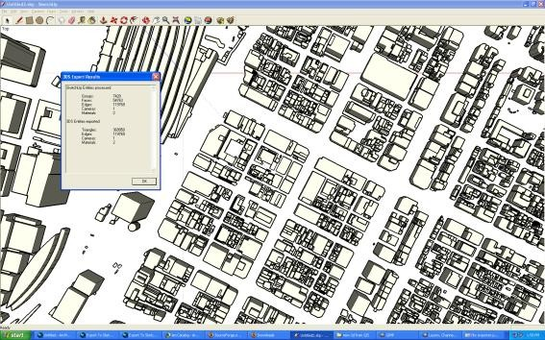
file format : 3DS filesize : 28 308KB
proprietary format of Autodesk (Autodesk 3DS Max, AutoCAD)
basically it store information about mesh (location and dimension), material, camera and light

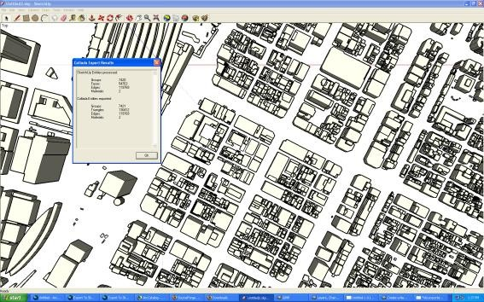
file format : DAE filesize : 46 613KB
Digital Assest Exchange is from Collaborative Design Activity for establishing an interchange file format for interactive 3D application.
Basically it is XML file and used in various 3D application because it is not proprietary based. store information about mesh, material and shader, physics content

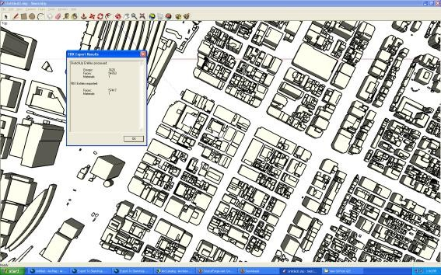
file format : FBX filesize : 49 286KB
proprietary format of Autodesk (Maya)
it store information about mesh, image maps, UV mapping.

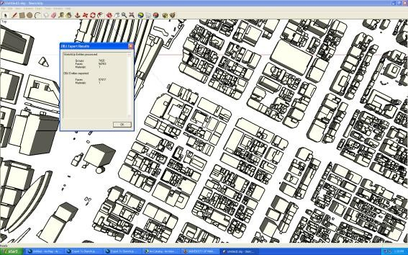
file format : OBJ filesize : 11 465 KB
proprietary format of Autodesk
basically it store information about mesh and material

From the table it can be concluded that the minimum file size is achieved by using .obj file format. Since 3D data mostly consist of simple polygons that represent buildings, the next step is to examine whether these polygons are constructed by using minimum vertices.

Figure 3 shows three characteristics of 3D data opened in Blender: number of object, number of vertices and memory usage. Result shows that although 3D data came from the same objects in ArcGIS, the number of objects varies. Number of vertices and memory usage follow accordingly. This issue is due to the file format specification.

 | OBJ | 3DS | DAE
Num.of object | 7421 | 14941 | 22361
Num. of vertex (K) | 79.8 | 838 | 159
Memory usage | 83.66 | 241.65 | 161.12

22500

Filetype Comparison

20000

17500

15000
OBJ 3DS DAE

12500

10000

7500

5000

2500

0
Num.of object Num. of vertex (K) Memory usage

Figure 3 File-types comparison.
The examination of each 3D polygon to reach minimum vertices usage is done by using semi-automatic method in Blender called Poly-Reduction¹. Basically, it will count vertices of each selected object, reduce the number of polygonal faces in particular mesh and scan if there is any vertex duplication. It is semi- automatic because it needs to do fix-up editing afterwards.

After applying Poly-Reduction method and performing some fix-up editing, it is clear that the number of vertices decreases. It also affects the file size and

¹ Semi automatic method in Blender, based on Python script

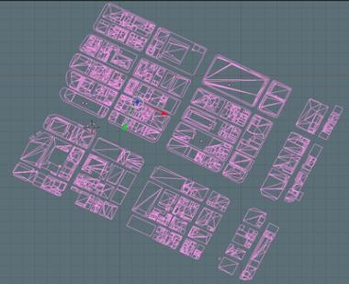
memory usage. Figure 4 shows the difference between scene before Poly- Reduction and after Poly-Reduction.
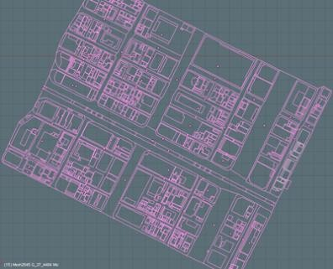
No Polygon Reduction  -Num. of objects : 1018  -Memory usage : 54.14 MB | Polygon Reduction  -Num. of objects : 318  -Memory usage : 51.83 MB
Figure 4 Polygon reduction and data comparison.

Visualization Techniques
In order to achieve graphic performance as appropriate as the most 3D rendering applications, we explored Unity3D capability to handle basic function such as large scale texture mapping and dynamic lighting (see Figure 5). The main factor taken into consideration is the balance between graphic performance and real-time simulation.
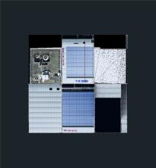
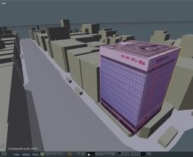
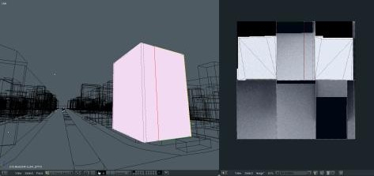

Applying final texture in 3D mesh in
Unity3D
Adjusting texture map with
orthographic photograph
3D Model in Blender, baked- lighting using ambience occlusion
technique to render texture map
Figure 5 Procedure of texture mapping and baked-lighting.

For such condition, there are two constraints of texture mapping to obtain greater performance both in graphics and game play (see Figures 6 & 7):
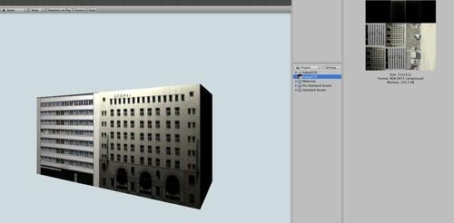

- Texture size must be as small as possible and visually appropriate.
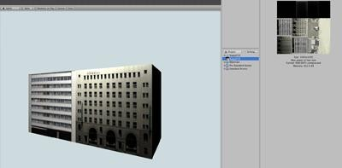
- Texture must be layered with baked-lighting information to get lighting effect (ambient occlusion) during game play.

-image size : original 1024 x 1024 pixel
-memory consume : 652 KB
-visual quality : high quality, antialiasing, detailed relief
-image size : 512 x 512 pixel
-memory consume : 170.7 KB
-visual quality : appropriate quality, nearly no-difference from 1000 x 1000 pixel
-image size : 256 x 256 pixel
-memory consume : 42.7 KB
-visual quality : poor and loose detail

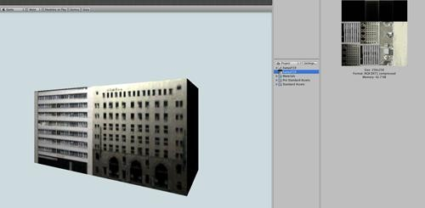
Figure 6 Comparison of texture size.

Texture Size and Memory Consumtion
700

650
600
550
500
450
400
Memory Usage (KB)
Total Memory Usage (MB)
350
300
250
200
150
100
50
0
1000 pixel 512 pixel 256 pixel

Figure 7 Memory size comparison.

As result, for further development in Unity3D we mainly use 2D texture in 512 x 512 pixel resolution.

Interaction Technique
Virtual reality in game-based environment consists of two parts: game world (game environment and all game objects) and game design (game scenario that determines how the game will be played and how the game world would interact with the user or with other game objects).

Our first intention on investigating Unity3D is to explore its ability as a tool for design study, how it differs from any other available 3D applications or any 3D viewer and presentation authoring applications and what is the advancement (see Table 4).

Therefore before we expand our investigation, we start with architecture design point of view. We regard game engine as an engine to develop our tool therefore it is important to consider aspects of design study to be incorporated in this application and at the same time investigating the method and technique to accommodate such requirements.

Table 4 Game design and requirements.

Game Design | Unity3D- based application | Other applications
create 3D environment which visual quality balance with the game performance | maximum visual quality for real world representation, i.e  : light and shadow, alpha channel, texture map, time- frame independent animation | less visual quality features (VRML, Flash-based)
create system of navigation which allow user to explore with maximum degree of freedom | allow maximum degree of freedom to explore and navigate in virtual environment | pre-programmed animation sequence (3D animation), less flexible freedom of movement (QuickTime VR)  view direction, high degree of navigation system (Bentley-3D PDF)
create system of navigation which allow user to examine particular object of interest in various way of perspectives | method to enhance spatial comprehension | view direction, high degree of navigation system (Bentley-3D PDF)
create method to incorporate various type of information | rich content and other data bounding technique | require script language and server- based interaction (Flash-based)
create method to accommodate flexible 3D data exchange | method for 3D data interchangeable to external tool | less flexible to perform data synchronization (Flash-based and other animation packages)
create a method to translate conventional analysis study | method to perform some basic visual-based analysis | less flexible
flexibility to expand game design | Object-oriented programming

Navigation
The navigation system is the main important to be considered in this application. As for a tool to examine 3D world, the main considerations of developing navigation system are:
- It must be easy to learn, easy to remember and easy to use with maximum intuitive level as possible.
- It must have rich features on minimum key input

As navigation system is crucial both for exploration and comprehension of 3D environment, we then elaborate the design of navigation system into the following criteria:
- There are two main navigation systems: Human Eye View (HEV) (First Person Camera) and Bird Eye View (BEV). Both are triggered by mouse stroke on an icon.

- On each navigation method, instead of using icon-based navigation panel for pan, zoom, orbit and others (see Figure 8), each method has contextual button using mouse-keyboard stroke combination.
In BEV:
  - zoom: using mouse scroll wheel
  - orbit: using mouse movement
  - pan: using mouse left click – and drag
-
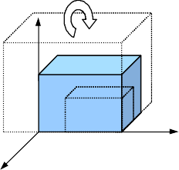
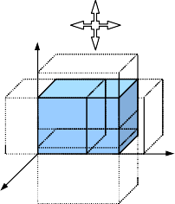
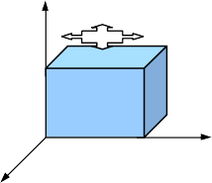

Figure 8 Pan, zoom and orbital navigation using mouse.

- In FPS, we use standard view navigation for FPS game (see Figure 9) :
  - look and turn : using mouse movement
  - walk forward : using key “w”
  - walk backward : using key “s”
  - slide left : using key “a”
  - slide right : using key “d”

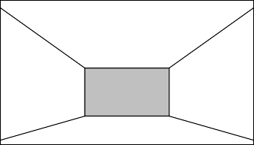
w
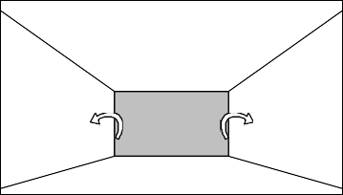
a 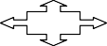 d
s
Figure 9 Turn/look and move toward direction using mouse and keyboard combination.
All these navigation system are programmed using Unity3D JavaScript since it does not provide any built-in navigation system as available on previous web- based applications.

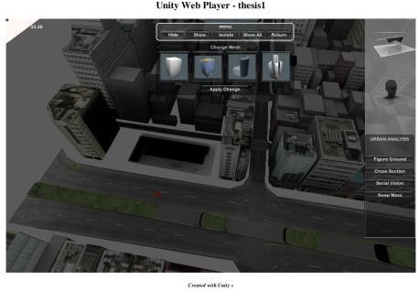
Snapshot Function
HIDE/SHOW
Hide selected object and show selected object

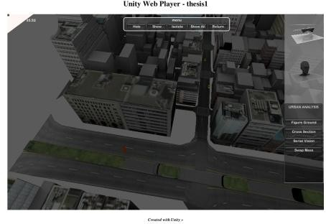
ISOLATE/ SHOW ALL
Isolate : hide unselected objects in the same building's lot

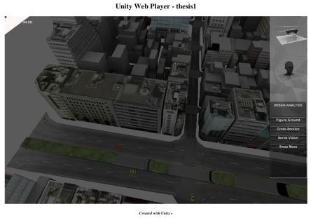
RETURN
Back everything to normal

Figure 10 Snapshot of interaction functions.

Interaction
Main considerations behind an interaction system are:
- object manipulation: select, hide, show, isolate, swap
- information retrieval : text, image, video
Object manipulation method is a feature that allows user to select any particular objects and perform such task that has effect on those objects. It mainly focuses

on the interaction in such a way that the user has the focus on this particular object. The manipulation method provides hide/show selected object or hide/show other objects, and isolates particular object from others (see Figure 10).

In the context of design study and urban design study in particular, virtual environment with this kind of interaction gives user flexibility to examine and to comprehend objects and its context. Combined with a navigation system, this application can be used as a tool for conducting urban-scale visual representation with advancement in flexibility to manipulate objects at real time.

In addition, we develop another feature named: Swap Object. This feature allow user to change selected mass or object with new mass from the preset gallery (see Figure 11). The main reason to put such a feature in is to allow user examines the effect of design transformation on 3D objects and its surrounding environment. This feature is not available in any previous applications.

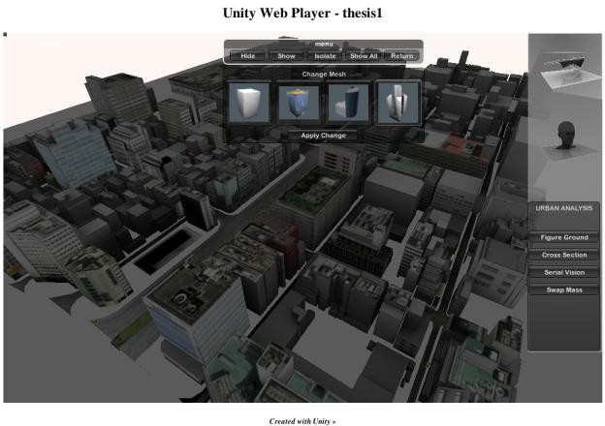

Figure 11 Snapshot of swap objects.

Another function to push the ability of a game engine as tool for interactive visualization is interactive animation. In this case we are about to show an animation of building process within the game environment (see Table 5 and Figure 12). We promote a new way to represent architectural or urban design by combining animation and interactivity in game environment.

In game engine-based environment, animation can be bound by using its object and key frame information. Unity3D translates this information and wrap-up

animation at runtime. As a result, the animation can be viewed from any viewpoint.

Table 5 Type of animation techniques.

Type of animation representation |  | Property
Conventional Animation | static, user become spectator, no interactivity.
Interactive visualization using authoring software | static, user engage with application using point-click method and others. 2D animation
Interactive visualization using game engine | dynamic, user engage with application in 3-dimensional world
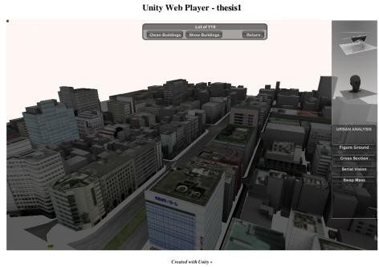  Building's lot selected, user can hide the buildings |  | 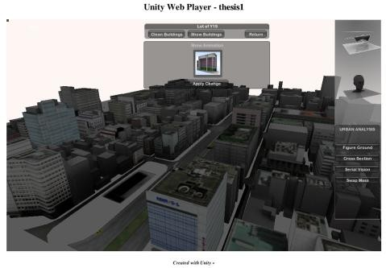  Animation sequence on selected object
User can examine animation from any view point |  | Snapshot after animation completed
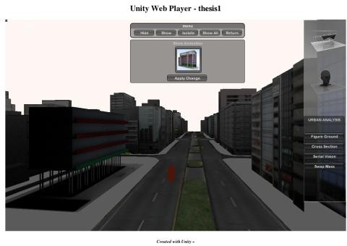
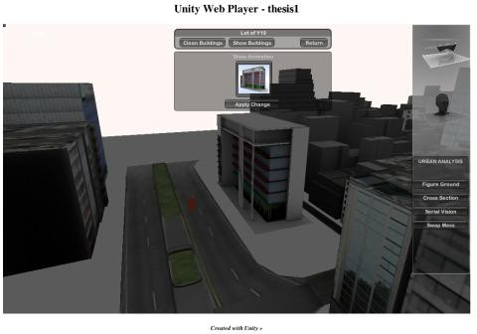
Figure 12 Snapshots of interactive animation.

Conclusion
We found some findings on evaluation of Unity3D game engine as a tool for design study by examining the aspects of visualization and interaction. By considering these two factors, we emphasize on the data compatibility between Unity3D game engine and CAD/GIS software (Blender, AutoCAD, ArcGIS). This compatibility and interoperability of game engine has significant factor for the integration of digital design tools.

From the experiment, we found significant improvement of CAD data compatibility in Unity3D as it can natively read most CAD file types. Furthermore, seamless integration between game engine and CAD applications makes file synchronization possible. We experienced that .obj file format is the most effective format to be exported to Unity for meshes as .fbx to animation.

For the interaction mechanism we created scripts and develop basic interaction system that engages users within this virtual environment. From one side of view, Unity3D JavaScript-based language gives freedom to create interaction system based on our own preference and ideas. Some of 3D navigation systems that we created are learned from other applications such as Google Earth, Adobe 3D PDF, Corona VRML player and others.

Object oriented programming language also gives an advantage in the way that any interaction method came from game object behavior and it responds to user interaction. The script-based interactions also open possibility to create an interaction system that bounds external data into game object. For example, we bound external data of text, image, and video into game interaction.

Although Unity3D has the potential to facilitate the development of an application that can be a 3D viewer and 3D simulation with interaction features at the same time, it has some limitations regarding to its function as a general purpose game engine application, which leads to some restraint conditions particularly in non-computer science fields.

In architecture and urban design study, the limitation comes mostly by the fact that Unity3D has not been equipped with computer aided design tools that are usually embedded in such applications. As for visual representation tool with object-based interaction system that mostly done by using Boolean algorithm, Unity3D comes with appropriate features and capability in delivering such simulation.

References
- Hunt, E. & Waller, D., Orientation and Wayfinding: A Review, in ONR Technical Report N00014-96-0380, Office of Naval Research, Arlington, VA, USA, 1999.
- Schnabel, Marc Aurel, Architectural Design in Virtual Environment. Published PhD Dissertation, University of Hongkong, 2004.
- Oxman, Rivka, Digital Architecture as a Challenge for Design Pedagogy: Theory, Knowledge, Models and Medium, Journal of Design Studies 29 (2008), p.99-120, 2008.
- Fairuz, Shiratudin & Walid Thabet, Virtual Office Walkthrough Using a 3D Game Engine, Journal of Design Computing, 1V, 2002.
- Moloney, Jules & Lawrence Harvey, Visualization and ‘Auralization’ of Architectural Design in a Game Engine Based Collaborative Virtual Environment, Proceeding of the 8th International Conference of Information Visualization, 2004.
- Eshaq, Ahmad Rafi & Peter Karboulonis, The Importance of Virtual Environment in The Design of Electronic Games and Their Relevance to Architecture, Proceeding of the 18th International Conference of eCAADe, 2000.
- Bermudez, Julio & Kevin King, Media Interaction and Design Process: Establishing A Knowledge Base, Journal of Automation in Construction 9 (2000), p.37-56, 2000.
- Calderon, Carlos & Marc Cavazza, Using Games Engine to Implement Intelligent Virtual Environments, Proceedings of the 2nd International Conference on Intelligent Games and Simulation (GAME-ON 2001), 2001.
- Andreoli, Roberto, et al., Interactive 3D Environments by Using Video Games Engines, Proceedings of the 9th International Conference in Information Visualization. IEEE, 2005.
- Tokyo Digital Map Corporation © 2007.
译文：

关于将Unity3D游戏引擎应用于中国的调查报告
建筑和城市设计项目的研究生
芝浦理工学院设计与工程系
东京都港区芝浦3-9-14 邮编108-8548 日本
电子邮件 aswinindra@gmail.com
建筑和城市设计课程教授。
芝浦理工学院设计与工程系。
东京都港区芝浦3-9-14 邮编108-8548 日本
电子邮件 sinozaki@shibaura-it.ac.jp

摘要.通过使用游戏引擎开发虚拟3D环境是将各种多媒体数据纳入一个平台的策略。游戏引擎的特点是预先安装了互动和导航工具，允许用户探索和参与游戏对象。然而，大多数CAD和GIS应用程序并没有配备为了满足使用经验的需要的3D工具和导航系统。特别是，3D游戏引擎提供了标准的3D导航工具，以及任何可编程的视图以创建引人入胜的导航深入虚拟环境。 通过使用游戏引擎，有可能创造出其他的互动，如物体操作、非游戏角色（NPC）与玩家和/或环境的互动。我们对以前的游戏引擎进行了分析，并在城市设计项目中使用Unity3D游戏引擎进行了可视化和互动性的实验。最后，我们介绍了使用游戏技术作为建筑和城市设计研究的视觉表现工具的优势和局限。
关键词：建筑；游戏引擎；互动虚拟环境；城市设计 研究；视觉表现。

1 超越建筑可视化
建筑和城市设计总是关于视觉化的想法和具体化。视觉化的重要性是如此的关键，以至于两个维度和三维图形在设计阶段占据了大部分的位置。 纵观历史，建筑图纸成为建筑师的主要媒介以向社会提出想法和愿景。对于社会（或客户）来说，想法和愿景的信息比技术或工程图纸参考更重要，这并不奇怪。建筑可视化一词指的是 建筑师用来向客户传达想法的媒体。
建筑可视化的趋势是使现实世界的描述尽可能逼真，甚至是超逼真。由于计算机处理器的速度和内存空间的增加，这种趋势也需要巨大的计算机资源来渲染和制作可视化序列的动画。建筑可视化的基本作用不再仅仅是为了交流，而是为了更广泛的范围和功能，如协作设计过程和市场营销。设计可视化不仅需要作为设计发展的高潮，也需要作为设计策略的输入。
2 目标
这项研究的目的是确定在城市设计研究中使用基于游戏引擎的视觉表现工具的优势和局限。通过了解它的潜力和局限性，我们能够开发新的视觉表现媒体，将CAD应用与实时互动动画相结合。
3 相关研究
基于游戏引擎的特定城市区域环境可以成为协助政策制定者和每个利益相关者在设计研究和过程中进行3D视觉模拟的工具[1, 2]。Oxman指出[3]，作为可视化工具的基础，游戏引擎的基本优势是通过重复使用其内置功能，如渲染引擎、导航和交互工具来节省实施时间。现代游戏引擎提供了高速、高质量的渲染、交互性和多用户支持，这是任何现有的可视化工具都难以做到的。
3.1 视觉化工具的游戏引擎
游戏引擎的使用已经在各种性质的项目下得到了发展。通常，游戏世界是通过从特定的CAD/3D应用程序中导入其整个对象而建立的。在这种情况下，一个特定的游戏引擎，通常与游戏本身一起成为一个平台，在这个平台上进行修改或修改的过程。为建筑可视化的目的修改游戏层面是很刺激的，因为它为实时数据渲染和操作打开了游戏引擎。
Fairuzet.al[4]研究发现，在可视化领域，游戏引擎可以快速开发模型，并在基于游戏引擎的应用中部署纹理和光照效果，对高端计算机规格没有进一步要求。在这项研究中，我们研究了以前的三项研究结果，这些研究试图使用三种不同的游戏引擎作为可视化工具。尽管每个引擎都有很多技术规范，但我们把重点放在主要功能的研究上，如三维几何数据的输入/输出，以及照明和纹理映射。之所以这样考虑，主要是因为这些基本功能是最重要的功能，可以发挥3D渲染和动画软件的优势。
本研究的摘要由表1描述。
表1 用于可视化的游戏引擎摘要。
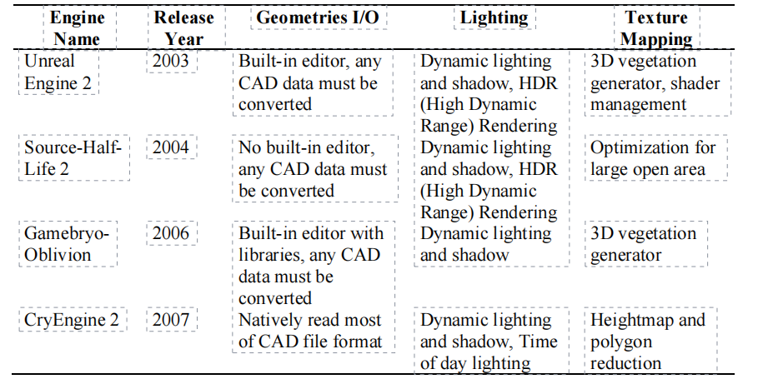尽管所有这些引擎都表现出在比三维渲染和动画软件更短的生产时间内产生动态可视化的能力，但使用这些游戏引擎作为可视化工具的主要限制在于其灵活性[5, 6]。三维几何数据在游戏引擎中使用时必须进行转换。因此，没有反馈或与3D/CAD软件的互动机制，建筑师们用它来制作设计对象。
3.2 互动性工具的游戏引擎
除了视觉化，虚拟环境也有可能让用户参与互动和交流系统。虚拟环境只有在支持物理上真实的行为时才会有用[7]。重要的逼真行为的类型取决于具体的应用。在建筑和城市设计中，我们通常要求空间环境的逼真表现，具有自然的效果，以及居住在其中的动态元素。此外，对于能够提高空间意识和理解力以进一步做出更好的设计决策的交互式工具来说，重要的是要考虑用户如何与游戏对象进行交互，然后我们如何检查发生了什么交互。
我们研究了以前两个使用游戏引擎中内置交互性工具的项目的结果[8, 9]。由于交互性是任何三维渲染和动画软件都不提供的元素，因此考虑该功能的易用性以提高建筑可视化的质量是很重要的。表2提供了以前的研究结果的摘要。表2提供了以往研究结果的总结。
表2 互动的游戏引擎摘要。
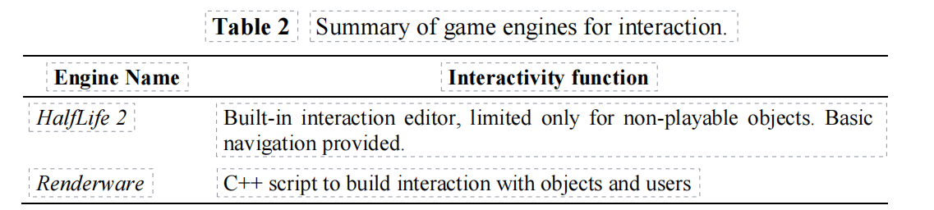
这两个发现都导致了使用的便利性或学习曲线。脚本机制是使用游戏引擎建立交互性的主要问题。对于建筑甚至城市设计研究的使用，交互系统是基于这样的假设：我们可以实时观察、检查以及探索我们想要交互的任何物体。这种需求可能需要脚本编程，以获得高的灵活性和自由度来实现这些目标。
4 使用Unity3D游戏引擎构建虚拟城市
在我们的研究中，我们使用Unity3D游戏引擎作为第四代游戏引擎，在几何数据的输入和输出方面，它结合了视觉模拟功能和互动功能，并易于使用。我们指出，由计算机完成的建筑可视化有以下缺点。
a.功能上的缺陷：它倾向于将设计过程和可视化的过程分开。甚至更进一步，现在的图形投影在设计过程中没有任何好处。可视化是最终产品，没有像以前那样的设计工具的功能。
b.资源不足：只要有足够的资源，追求计算机渲染或动画的真实性是没有限制的。这种依赖性的趋势是无效的、低效的。设计方案的重点可能被视觉设施所忽略。
c.技术缺陷：在3D应用中，CAD可能已经被其他技术甩在后面。游戏引擎是未被开发的技术，为设计过程提供了更多的生产和有效的帮助。技术，为设计提供更多的生产力和有效的帮助 。
通过使用Unity3D游戏引擎构建虚拟城市，我们探索了它的能力以及它的局限性，重点是设计过程。
案例研究是位于东京中心区的已开发城市区域，即八重洲区。这个地区大约有220 000平方米，计划成为新的开发区。八重洲地区主要由办公和商业中层建筑组成，其中许多是登记在册的旧建筑。
虚拟城市环境的开发过程遵循图1所示的顺序。从GIS应用程序（ArcGIS）获得的三维几何数据由私人公司[10]准备成*.obj格式，以便在Blender应用程序中进行解释。
图1 构建虚拟城市的框架。
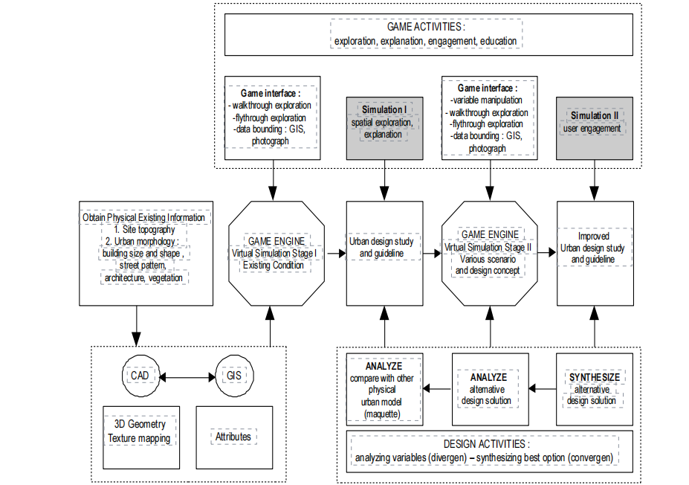
在城市的范围内，多边形和纹理映射系统的复杂性成为主要的考虑因素。GIS应用程序提供了三维多边形导出器，但不包括任何纹理映射系统。在本案例研究中，只有建筑物在ArcGIS中拥有其三维几何数据。每个建筑外墙的正射照片都是从一家测绘服务公司获得的。本研究在Blender3D软件中使用了减少多边形的技术和使用un-wrap技术进行纹理映射，以解决多边形的复杂性和映射系统的问题。图2显示了整个三维建造的详细过程。
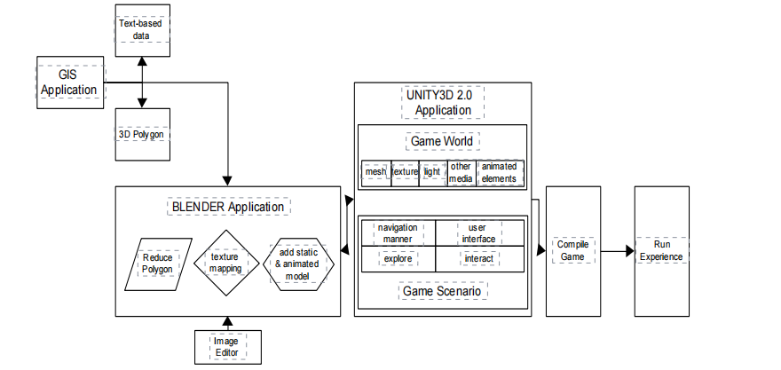
图2 整体过程。
本研究中构建虚拟环境的方法可以分为以下几个阶段。
1.游戏世界阶段：包括3D数据的采集和开发，其他静态游戏对象如植被、路灯等城市家具，以及作为城市元素的动画游戏对象，如车辆、汽车等。其他以及作为城市元素的动画游戏对象，如车辆。类人角色。
2.游戏场景开发阶段，包括导航系统和交互系统。
4.1 数据采集
游戏世界的构建始于3D数据的获取。为此，本研究使用东京数字地图公司提供的基于GIS的ARC GIS的三维数据。通过使用ArcGIS提供的几种文件格式导出器来自动获取三维数据。表3显示了每种文件格式的特点及其产生的文件的大小。
表3 文件类型和数据大小。
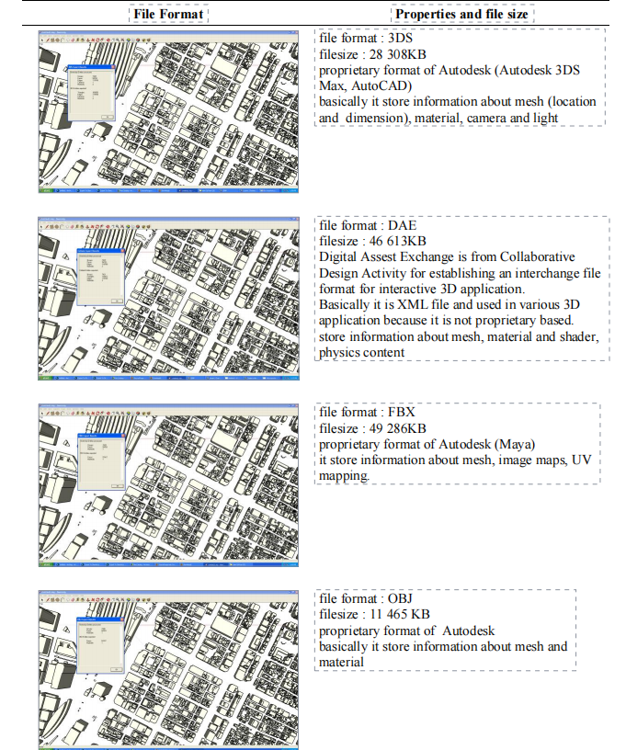A
从表中可以得出结论，最小的文件大小是通过以下方式实现的 使用.obj文件格式。由于3D数据大多由简单的多边形组成，所以 代表建筑物，下一步是检查这些多边形是否是 通过使用最小顶点构建。
图3显示了在Blender中打开的3D数据的三个特征：数量对象、顶点数量和内存用量。结果显示，虽然3D 数据来自ArcGIS中的相同对象，对象的数量不尽相同。
顶点的数量和内存的使用也相应地增加。这个问题是由于文件格式规范。
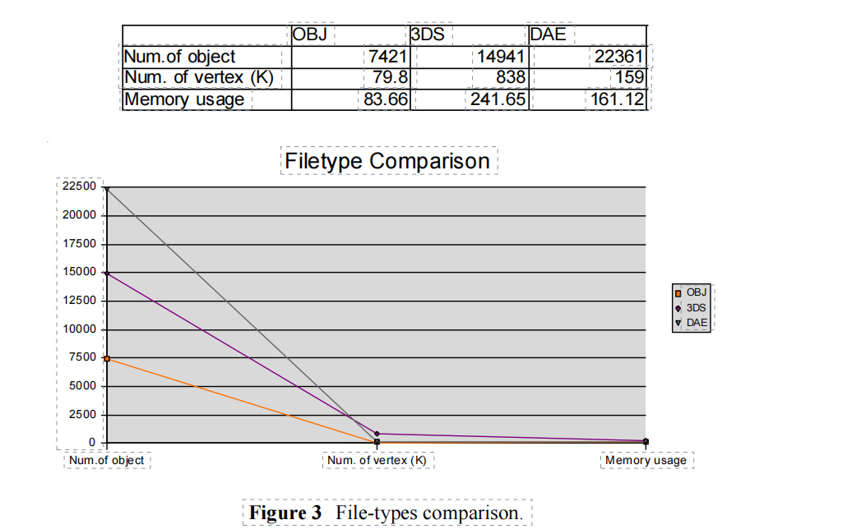

检查每个三维多边形以达到最小的顶点使用量是通过使用Blender中的半自动方法Poly-Reduction1完成的。基本上，它将计算每个选定对象的顶点，减少特定网格中的多边形面的数量，并扫描是否有任何顶点重复。它是半自动的，因为它需要在事后进行修复编辑。在应用Poly-Reduction方法并进行了一些修复性编辑之后，很明显顶点的数量减少了。这也影响了文件的大小和内存的使用。图4显示了Poly-Reduction之前和Poly-Reduction之后的场景的差别。
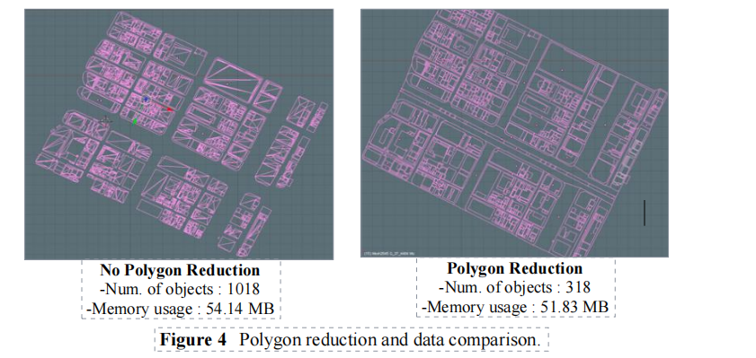
图4 多边形缩小和数据比较。
4.2 视觉化技术
为了达到与大多数三维渲染应用一样的图形性能，我们探索了Unity3D处理基本功能的能力，如大规模的纹理映射和动态照明（见图5）。考虑到的主要因素是图形性能和实时模拟之间的平衡。
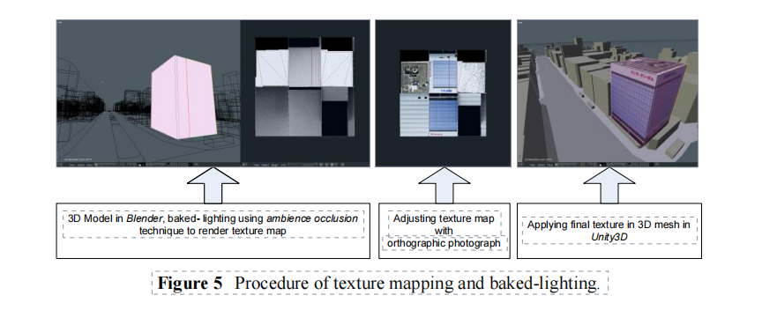
图5 纹理贴图和烘烤光线的程序。
对于这样的条件，有两个纹理映射的限制，以获得更大的图形和游戏性能（见图6和7）。
1.纹理尺寸必须尽可能小，并且视觉上合适。
2.纹理必须与烘烤照明信息分层，以便在游戏过程中获得照明效果（环境遮挡）。
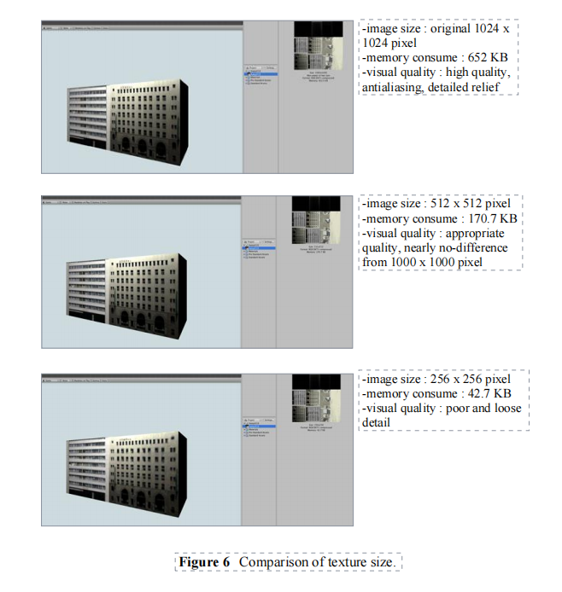
图6 纹理大小的比较。
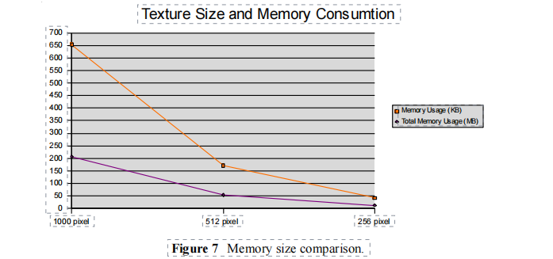
图7 内存大小比较。
因此，在Unity3D的进一步发展中，我们主要使用512 x 512像素分辨率的2D纹理。
4.3 交互技术
基于游戏的环境中的虚拟现实由两部分组成：游戏世界（游戏环境和所有游戏对象）和游戏设计（决定如何进行游戏以及游戏世界如何与用户或其他游戏对象互动的游戏场景）。
我们调查Unity3D的第一个意图是探索它作为设计研究工具的能力，它与其他任何可用的3D应用程序或任何3D查看器和演示文稿制作应用程序的区别，以及它的优势是什么（见表4）。
因此，在我们展开调查之前，我们先从架构设计的角度出发。我们把游戏引擎看作是开发我们工具的引擎，因此，重要的是要考虑设计研究的各个方面，以纳入这个应用程序，同时调查方法和技术以适应这些要求。
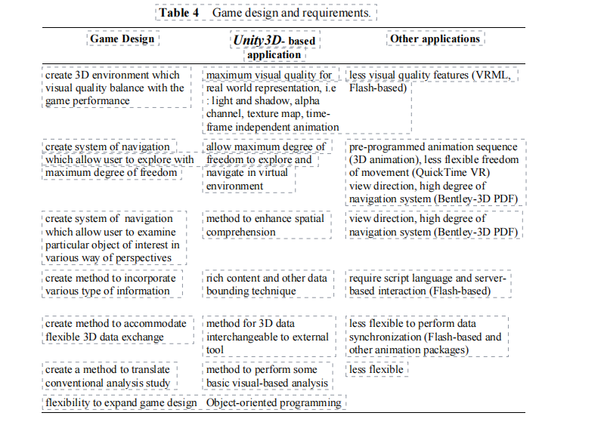
表4 游戏设计和要求。
4.3.1 导航
导航系统是该应用中需要考虑的主要问题。对于一个考察三维世界的工具来说，开发导航系统的主要考虑是。
1.它必须易于学习，易于记忆，易于使用，并尽可能达到最直观的水平。
2.它必须具有丰富的功能，只需最少的按键输入，因为导航系统对于探索和理解三维环境都是至关重要的。环境的关键，因此我们将导航系统的设计细化为
以下标准。
- 有两个主要的导航系统。人眼看世界（HEV）（第一人称照相机）和鸟眼看世界（BEV）。两者都是通过鼠标在图标上的划动来触发的。
- 在每个导航方法中，没有使用基于图标的平移、缩放、轨道和其他导航面板（见图8），每个方法都有使用鼠标-键盘笔画组合的上下文按钮。
- 在BEV中：-缩放：使用鼠标滚轮
- -轨道：使用鼠标移动
- -平移：使用鼠标左键和拖动
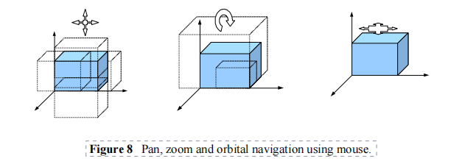
图8 使用鼠标进行平移、缩放和轨道导航。
3.在FPS中，我们使用FPS游戏的标准视图导航（见图9）。
- 看和转：使用鼠标移动
- 向前走：使用 "w "键
- 向后走：使用 "s "键
- 向左滑动：使用 "A "键
- 向右滑动：使用 "d "键
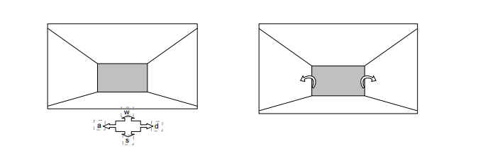
图9 使用鼠标和键盘转动/查看并向方向移动
所有的导航系统都是用Unity3DJavaScript编程的，因为它没有像以前基于网络的应用程序那样提供任何内置的导航系统。
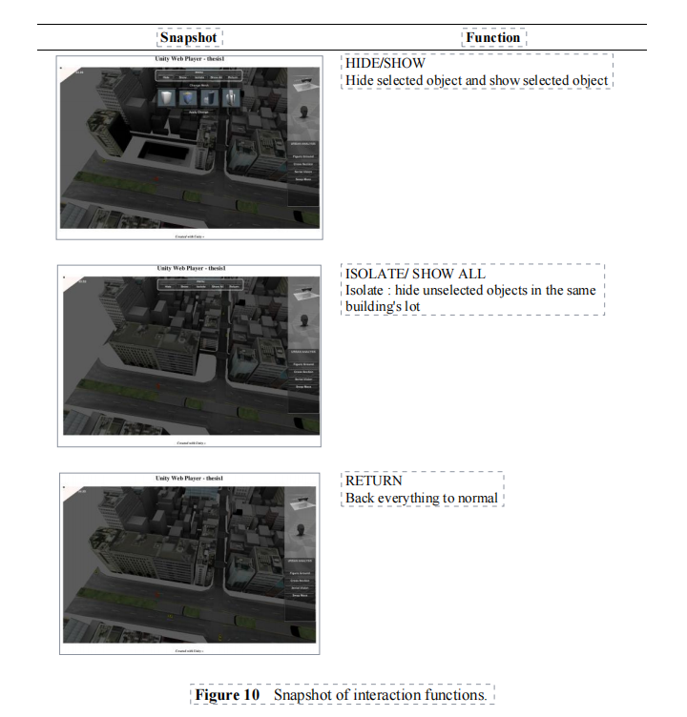
图10 互动功能的快照。
4.3.2 相互作用
交互系统背后的主要考虑是：
1.对象操作：选择、隐藏、显示、隔离、互换
2.信息检索：文本、图像、视频
对象操作方法是一种允许用户选择任何特定对象并执行对这些对象有影响的任务的功能。它主要侧重于互动，使用户的注意力集中在这个特定的对象上。操作方法提供了隐藏/显示所选对象或隐藏/显示其他对象，并将特定对象与其他对象隔离开来（见图10）。在设计研究，特别是城市设计研究的背景下，具有这种交互方式的虚拟环境使用户能够灵活地检查和理解对象及其背景。与导航系统相结合，这个应用程序可以作为一个工具来进行城市规模的视觉表现，并在实时操纵物体方面有更大的灵活性。此外，我们还开发了另一个功能，名为：交换对象。此外，我们还开发了另一个名为 "交换物体 "的功能，该功能允许用户从预设库中用新的质量来改变所选的质量或物体（见图11）。设置这个功能的主要原因是允许用户检查设计转换对三维物体及其周围环境的影响。这个功能在以前的任何应用程序中都是不存在的。
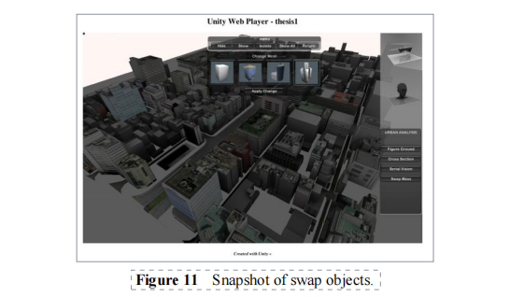

图11 交换对象的快照。
推进游戏引擎作为交互式可视化工具能力的另一个功能是交互式动画。在这种情况下，我们将在游戏环境中展示一个建筑过程的动画（见表5和图12）。通过在游戏环境中结合动画和交互性，我们提倡一种新的方式来表现建筑或城市设计。
在基于游戏引擎的环境中，动画可以通过使用其对象和关键帧信息进行绑定。Unity3D翻译这些信息，并在运行时将动画包装起来。因此，动画可以从任何视角观看。
表5 动画技术的类型。

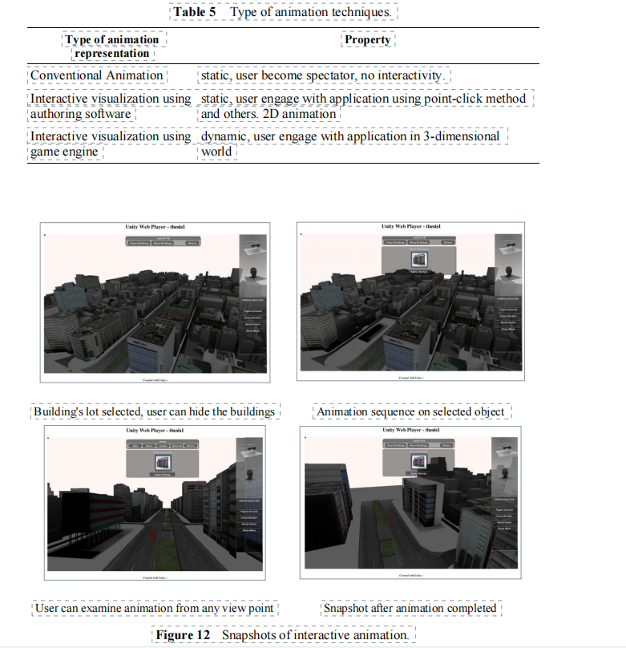
图12 交互式动画的快照。在城市设计研究中使用Unity3D游戏引擎的调查 17
5 总结
我们通过对可视化和交互性方面的研究，发现了一些对Unity3D游戏引擎作为设计研究工具的评价。通过考虑这两个因素，我们强调了Unity3D游戏引擎和CAD/GIS软件（Blender、AutoCAD、ArcGIS）之间的数据兼容性。游戏引擎的这种兼容性和互操作性对于数字设计工具的整合具有重要意义。
从实验中，我们发现Unity3D的CAD数据兼容性有了明显的改善，因为它可以原生地读取大多数CAD文件类型。此外，游戏引擎和CAD应用程序之间的无缝集成使文件同步成为可能。我们体验到，.obj文件格式是最有效的格式，可以导出到Unity的网格和.fbx的动画。
对于交互机制，我们创建了脚本并开发了基本的交互系统，使用户参与到这个虚拟环境中。从一个方面来看，基于Unity3DJavaScript的语言使我们可以根据自己的喜好和想法来创建交互系统。我们创建的一些3D导航系统是从其他应用程序中学习的，如谷歌地球、Adobe 3D PDF、Corona VRMLplayer等。
面向对象的编程语言还提供了一个优势，即任何交互方法都来自于游戏对象的行为，并且它对用户的交互作出反应。基于脚本的交互也为创建一个将外部数据绑定到游戏对象的交互系统提供了可能性。例如，我们将文本、图像和视频等外部数据绑定到游戏交互中。
尽管Unity3D有可能促进开发一个可以同时作为3D查看器和3D模拟的交互功能的应用程序，但它作为一个通用的游戏引擎应用程序的功能有一些限制，这导致了一些限制条件，特别是在非计算机科学领域。
在建筑和城市设计研究中，其局限性主要来自于Unity3D没有配备计算机辅助设计工具，而这些工具通常被嵌入到此类应用中。至于基于对象的交互系统的视觉表现工具，主要是通过布尔算法完成的，Unity3D具有适当的功能和能力来提供这种模拟。
参考文献
[1]
Hunt, E. & Waller, D., Orientation and Wayfinding:回顾，在ONR
技术报告N00014-96-0380，海军研究办公室，阿灵顿。
美国弗吉尼亚州，1999年。
[2]
Schnabel, Marc Aurel, 虚拟环境中的建筑设计。
已发表的博士论文，香港大学，2004年。
[3]
Oxman, Rivka, 数字建筑对设计的挑战
教育学。理论、知识、模型和媒介，《设计》杂志
研究 29 (2008), p.99-120, 2008.
[4]
Fairuz, Shiratudin & Walid Thabet, 《使用虚拟办公室的演练》。
3D游戏引擎，《设计计算杂志》，1V，2002。
[5]
Moloney, Jules & Lawrence Harvey, 视觉化和 "听觉化"。
基于游戏引擎的协作式虚拟世界中的建筑设计
环境，第8届国际会议论文集。
信息可视化, 2004.
[6]
Eshaq, Ahmad Rafi & Peter Karboulonis, 虚拟的重要性。
电子游戏设计中的环境及与之相关的问题
架构，第18届国际会议论文集。
eCAADe, 2000.
[7]
Bermudez, Julio & Kevin King, 媒体互动和设计过程。
建立一个知识库，建筑自动化杂志 9
(2000), p.37-56, 2000.
[8]
Calderon, Carlos & Marc Cavazza, 使用游戏引擎来实现
智能虚拟环境"，《第二届中国国际科技大会论文集》。
智能游戏和模拟会议（GAME-ON 2001）。
2001.
[9]
Andreoli, Roberto, et al., 使用视频的互动3D环境
游戏引擎，第九届国际会议论文集。
Information Visualization.IEEE, 2005.
[10] 东京数字地图公司©2007。

